**Final report**

Rathnayake Rathnayake - 10899210

**Introduction**

This final report represents the result of our efforts to improve Sri Lanka's tea export business, building on the thorough research and suggestions provided in the interim reports. With an eye towards improving the calibre of grading and promotion procedures, our path has been characterised by careful investigation, calculated forethought, and cooperative creativity. Through the implementation of customised solutions and the resolution of significant deficiencies, our goal is to strengthen the industry's sustainability and worldwide competitiveness. We offer a road map for a more reliable, consistent, and integrated approach to tea quality grading and promotion in this final report, which is expected to catapult Sri Lanka's tea export industry to unprecedented levels of prosperity and recognition.

**Tea quality grading**

* Suggested functionalities for the system

Weakness – outdated methods of grading tea, including the subjective assessments of human tasters are sometimes heavily relied upon in conventional grading systems, leading to discrepancies in grading criteria among individuals or grading panels. This subjectivity could lead to uneven grading decisions. Because different locations or estates may not employ the same standards or grading schemes, it can be difficult to compare the quality of tea produced by them using traditional grading procedures. This lack of uniformity further undermines the transparency and integrity of the grading process.

Solution – creating an electronic form in an application.  
Imagine tasters of tea in Sri Lanka who are armed with iPads that have digital grading forms on them. With a few taps and swipes, they can quickly and easily assess tea samples. Dropdown choices and checkboxes make grading as easy as getting your favourite tea online with these user-friendly forms. Tea tasters can enter grading judgements straight into the forms in real-time, even in remote tea farms, assuring accuracy and efficiency while on the road. Tailorable templates accommodate a variety of tea varieties, from robust black teas to delicate white teas, enabling customised grading guidelines. Tea tasters can also continue their evaluations offline, in the comfort of rustic tea warehouses or among verdant tea fields. Furthermore, strong data security protocols protect the accuracy of the grading process, guaranteeing that every cup of tea is assessed with the highest care and discretion. Tea tasters effortlessly adopt this digital revolution with thorough training and assistance, making tea grading a contemporary, effective, and enjoyable experience.

* ER diagram

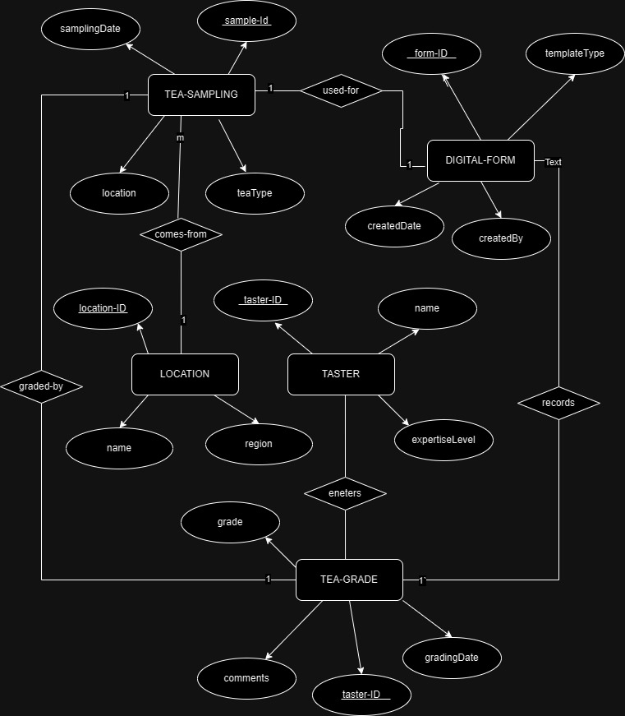

* User case diagram

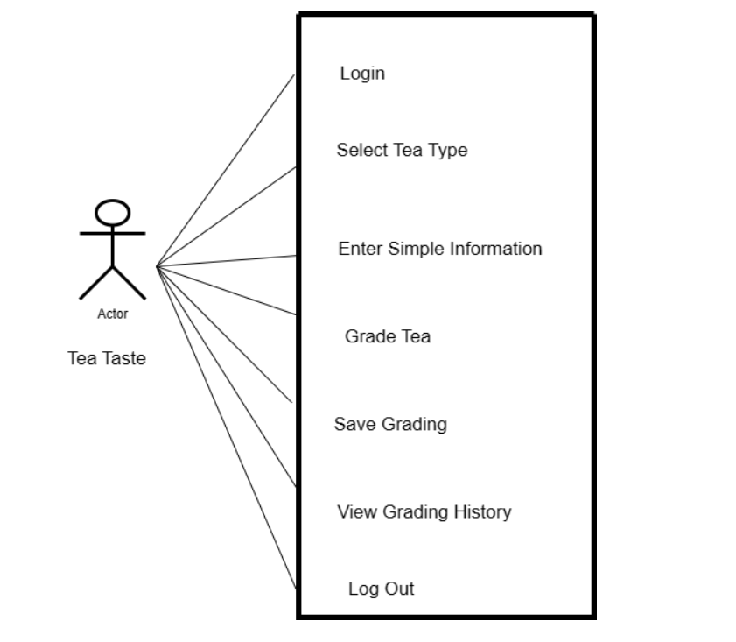

* UI designs

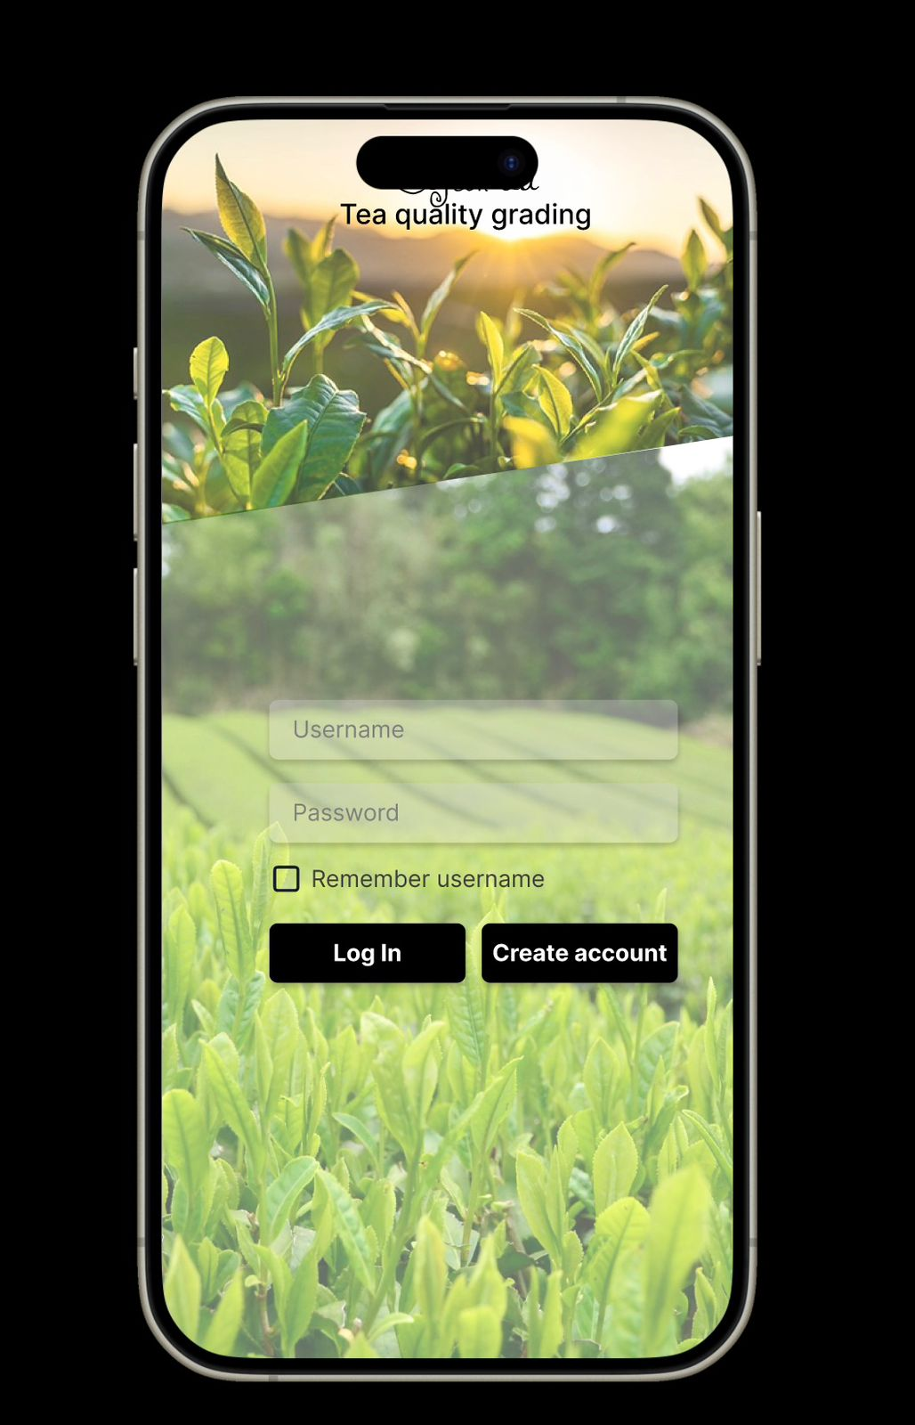

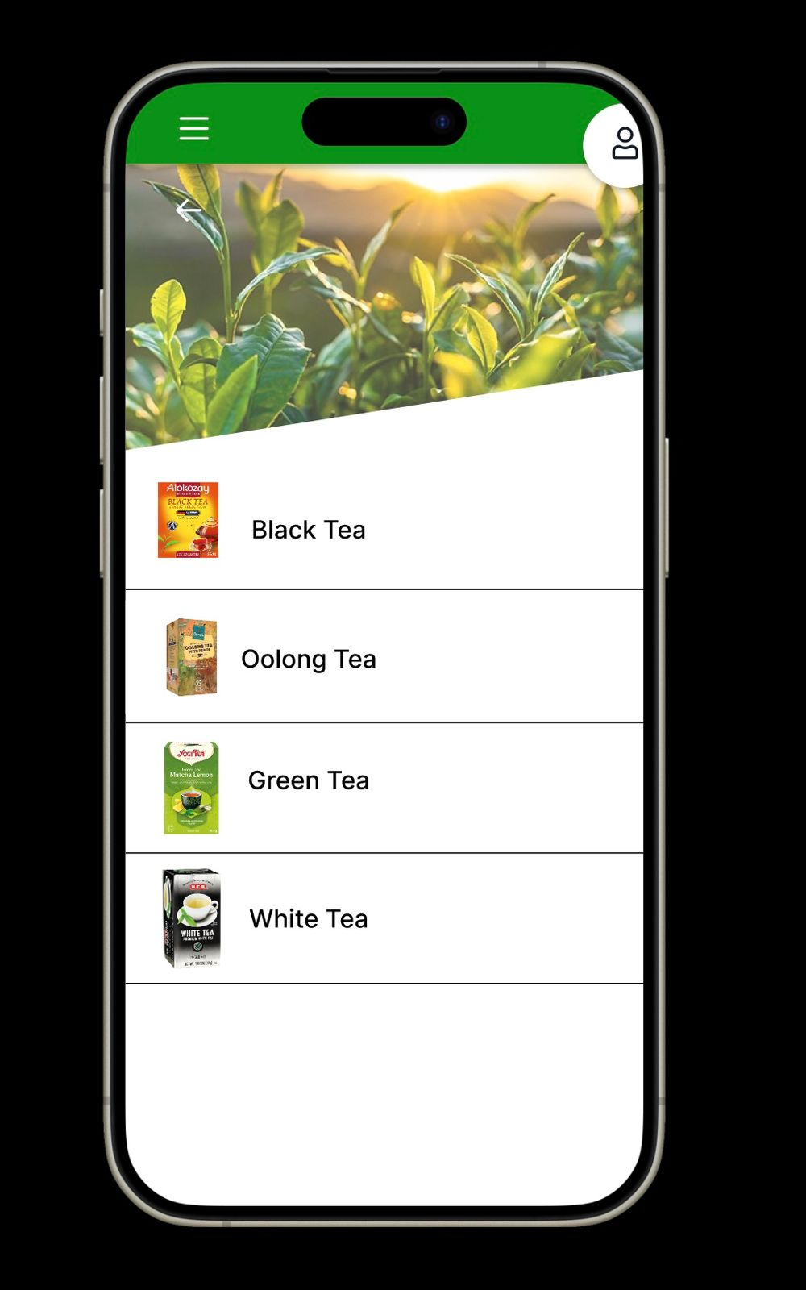

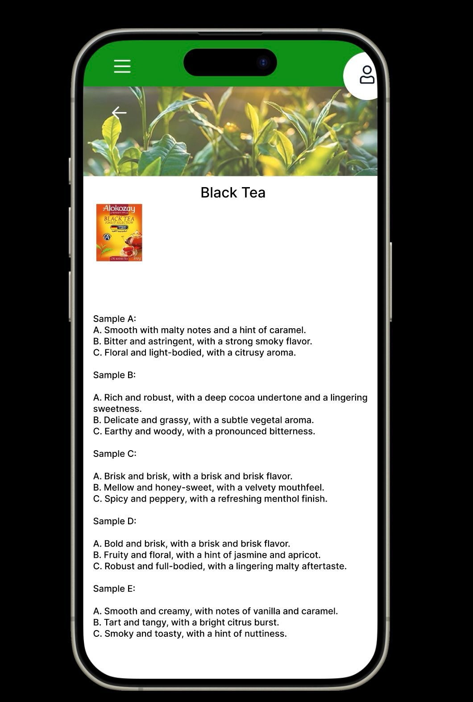

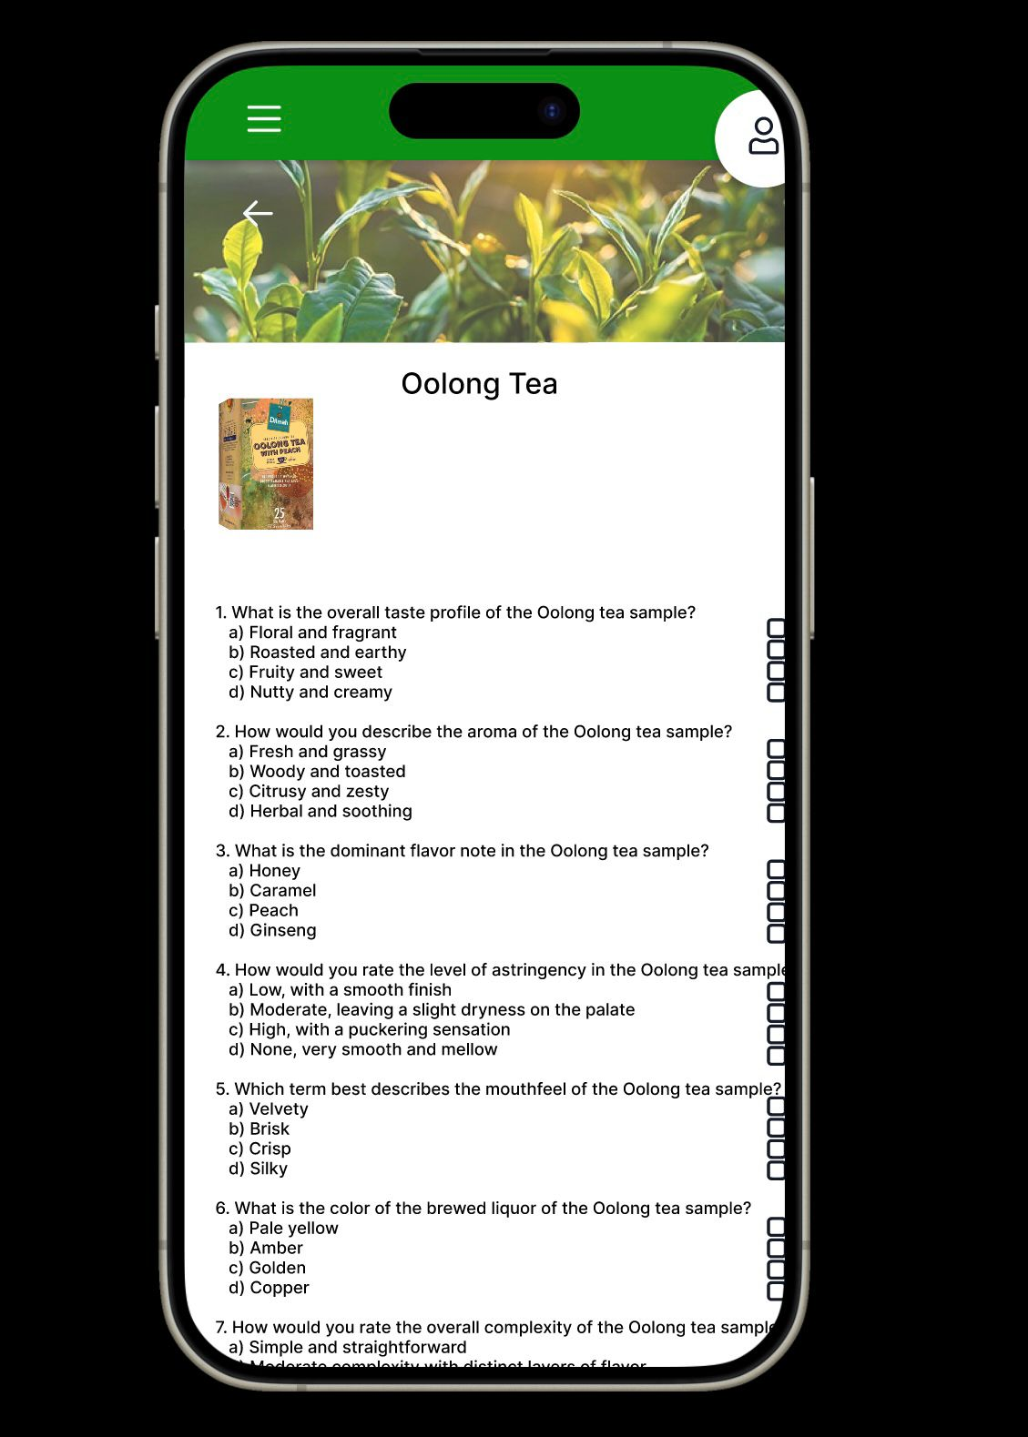

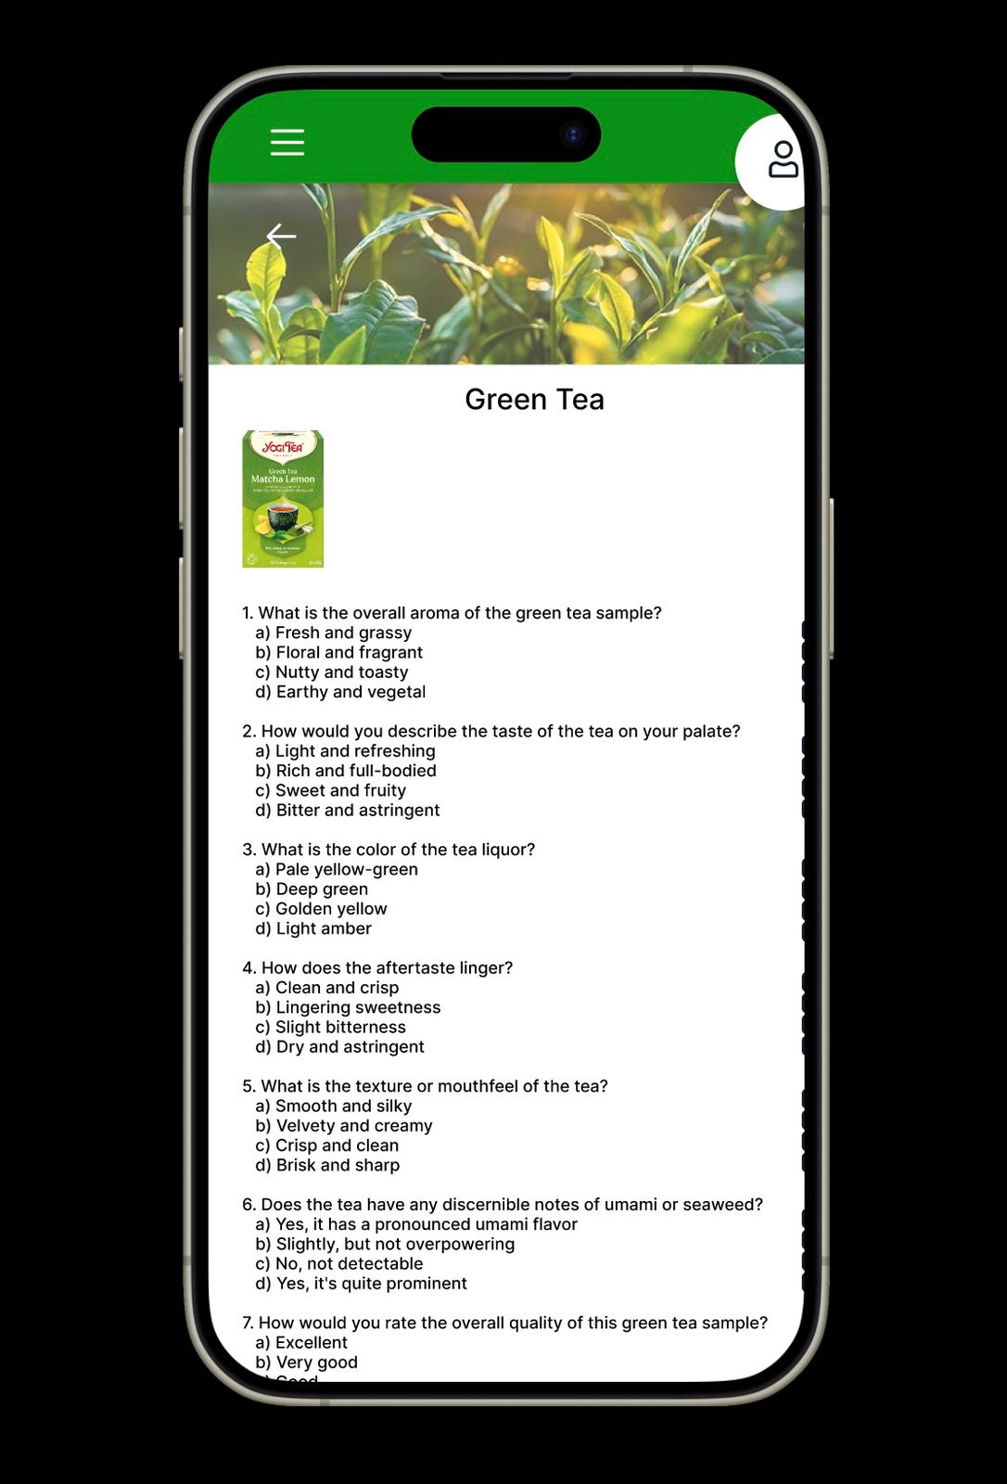

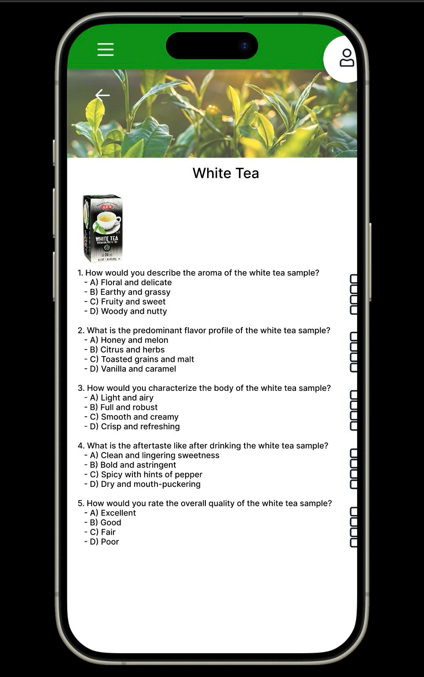



* Flow of the functionalities

User authentication and access control - Upon accessing the application, tea tasters will be required to authenticate themselves through either a unique set of credentials or a biometric approach. The grading forms and data are protected from unauthorised users by access control techniques.

Tea sample registration - The first thing users do is enter a fresh tea sample into the database. Hey enter pertinent details like the sort of tea, its origin, its estate, and any other pertinent information. For tracking purposes, a unique identifier is issued to each sample.

Grading forms selection - Depending on the kind of tea being evaluated (black, green, or white tea, for example), users choose the proper grading form template. For every type of tea, the programme offers customisable grading guidelines.

Real time grading - Users use text fields, checkboxes, and dropdown menus to complete the digital grading form. Using standardised criteria, they evaluate many aspects of the liquor, including its colour, fragrance, flavour, and appearance. Accuracy and efficiency are ensured by entering grading judgements in real-time.

Offline evaluation support - The programme enables assessment in isolated tea fields or places with spotty internet by allowing users to finish marking assessments offline. After an internet connection is restored, data that is offline is synchronised with the central server.

Data security and integrity - Robust data security procedures guarantee the integrity and privacy of grading information. Sensitive data is safeguarded during transmission and storage using encryption techniques.

Review and approval process - Tea tasters give their grading assessments, which are reviewed by supervisors or quality control managers. If necessary, they can override grading decisions or offer criticism.

Reporting and analysis - Based on grading data, the application produces extensive reports and analytics. Users can spot quality variances, evaluate trends, and decide on the best course of action for marketing and producing tea.

Training and support - To assist tea tasters in getting used to the digital grading procedure, the application provides training materials and other tools. Technical assistance is offered on an ongoing basis to resolve any problems or inquiries that arise throughout the grading procedure.

Continuous improvement - Based on user and stakeholder feedback, the system enables regular updates and improvements to the grading criteria and templates. Ongoing enhancement initiatives guarantee that the electronic grading system for evaluating tea quality is current and useful.

* Hardware/software requirements to deploy the system.
* Hardware

Tablets or iPads: For the tea tasters' application to function properly, tablets or iPads with a good amount of RAM and processing capability are required. For extended use during grading sessions, these devices should be able to connect to the internet reliably and have a respectable amount of battery life.

Networking Hardware: To guarantee smooth connection between the tablets or iPads tea tasters are using and the central server, dependable networking hardware, such as routers, switches, and access points, are required. For operations like data synchronization and real-time grading, reliable internet connectivity is essential.

Backup systems: To protect grading data from unintentional loss or corruption, backup mechanisms must be put in place. To guarantee data availability and integrity, this may entail automated backup procedures, disaster recovery strategies, and redundant storage options.

* Software

Operating System: The tea tasters' tablets or iPads should be running an application-compatible operating system. This could apply to Android or iOS, depending on the platform that is selected for app development.

Database Management System: To store and handle grading data effectively, a dependable database management system (DBMS) is required. Such programmes typically make use of SQL-based systems, such as MySQL or PostgreSQL, because of their strong feature set, scalability, and dependability.

security Software: To safeguard grading data from cyber attacks, unauthorised access, and data breaches, security software and processes must be put into place. To protect the confidentiality and integrity of data, this may use intrusion detection systems, access control lists, authentication procedures, and encryption methods.

* Special skills and knowledge required by the system users to work with

Technical Proficiency: Users should be able to use tablets or iPads, navigate through programmes, and use digital forms, especially tea tasters. They must to be accustomed to utilising touchscreen interfaces and know how to do simple operations like typing, swiping, and tapping.

Grading Proficiency: Tea tasters must be proficient in the assessment of aroma, flavour, appearance, and other sensory aspects of tea. They must to be knowledgeable about the subtleties of various tea kinds and skilled at differentiating between them in terms of quality.

Data Entry Proficiency: To accurately enter grading assessments into the electronic forms, users must possess strong data entry skills. They ought to be able to pick the proper alternatives from dropdown menus, complete the grading form, and provide detailed remarks as needed.

Knowledge of Grading Criteria: Users should be fully aware of the uniform grading standards that the system offers for various tea varieties. To evaluate the calibre of tea samples, they must correctly interpret and apply these standards.

Security Awareness: To protect grading data and uphold confidentiality, users should be informed about security standards and best practices. They ought to be aware of how crucial it is to safeguard login passwords, abide by data encryption regulations, and follow security procedures to stop illegal access and data breaches.

Instruction in System Usage: Adequate instruction is necessary to acquaint users with the characteristics and functions of the electronic grading system. To understand how to use the application, enter assessments for grading, access reports and analytics, and troubleshoot typical problems, users should attend training sessions.

Technology Adaptability: Users must be willing to embrace new technologies and adjust to digital workflows. They ought to be open to picking up the skills necessary to operate the electronic grading system correctly and eager to accept the advantages it provides in terms of effectiveness, uniformity, and correctness.

* Limitations of the system

When compared to conventional methods, the electronic tea grading system offers notable advances in efficiency and standardisation; however, it is important to take into account its limits. Reliance on technology increases the possibility of technical problems, and poor internet connectivity might make it difficult to get information in remote locations. Some users may not be as accessible due to device and operating system compatibility difficulties. Even with the training, there can be a learning curve while switching to the new system. Concerns about data security and grade subjectivity are natural ones. As the amount of grading data grows, scalability issues could surface, and implementation and maintenance costs need to be carefully controlled. Adoption and efficacy of the system may also be impacted by environmental and cultural factors. To fully realise the promise of the system in improving tea quality evaluation, it is imperative to address these constraints through strong assistance, continuous training, and adaptable techniques.

**Promotion and tourism**

* Suggested functionalities for the system

Weakness - most of the foreigners have no idea about the tourism accept of the tea factories. The industry loses out on possible tourist revenue streams if tea factory tours are not properly promoted and made public. If travellers are unaware of the opportunities offered, they can pass over Sri Lanka as a travel destination in search of a firsthand experience with tea manufacturing. Sri Lankan tea factories possess a wealth of resources, such as historical value, cultural heritage, and picturesque scenery. However, these resources remain underutilised and result in lost opportunities for economic growth and development in tea-producing regions if they are not actively promoted to attract tourists.

Solution – creating virtual tours

The introduction of virtual tours of tea factories and fields provide a viable answer to the problem of the lack of promotion and knowledge regarding tea tourism in Sri Lanka. People all over the world may now easily and entertainingly discover the beauty and complexities of Sri Lanka's tea business from the comfort of their own homes thanks to these virtual experiences. Viewers can learn about the whole tea production process, from leaf to cup, and receive insight into the cultural and historical significance of tea in Sri Lankan society through immersive multimedia components like audio narration and movies. Using the company website, and marketing efforts, these virtual tours function as effective promotional instruments, drawing in a larger audience and sparking curiosity about visiting Sri Lanka's tea-growing regions. Additionally, because they lessen the impact on the environment and highlight the industry's dedication to innovation, virtual tours are consistent with sustainable tourism standards. All things considered, adopting virtual tours is a progressive way to improve global promotion and understanding of Sri Lanka's abundant tea tourism options.

* ER diagram

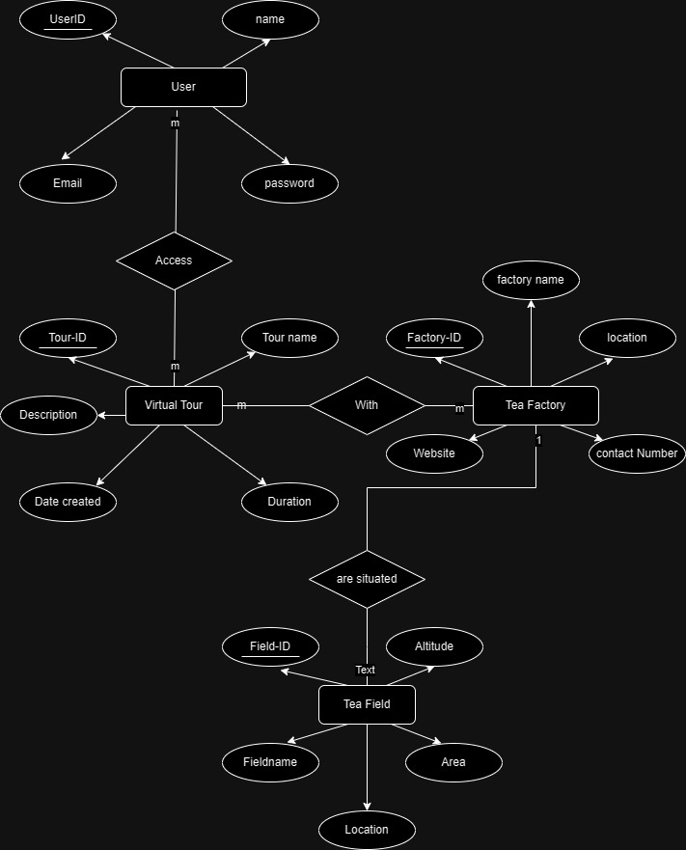

* User case diagram

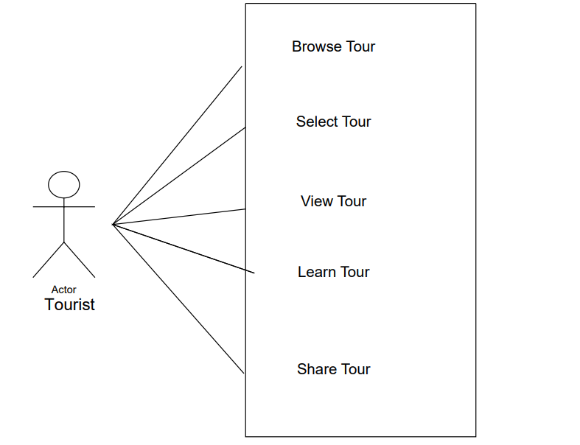

* UI designs

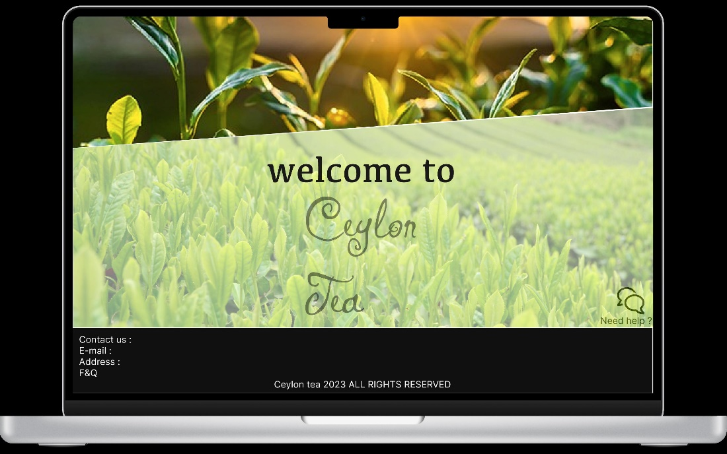

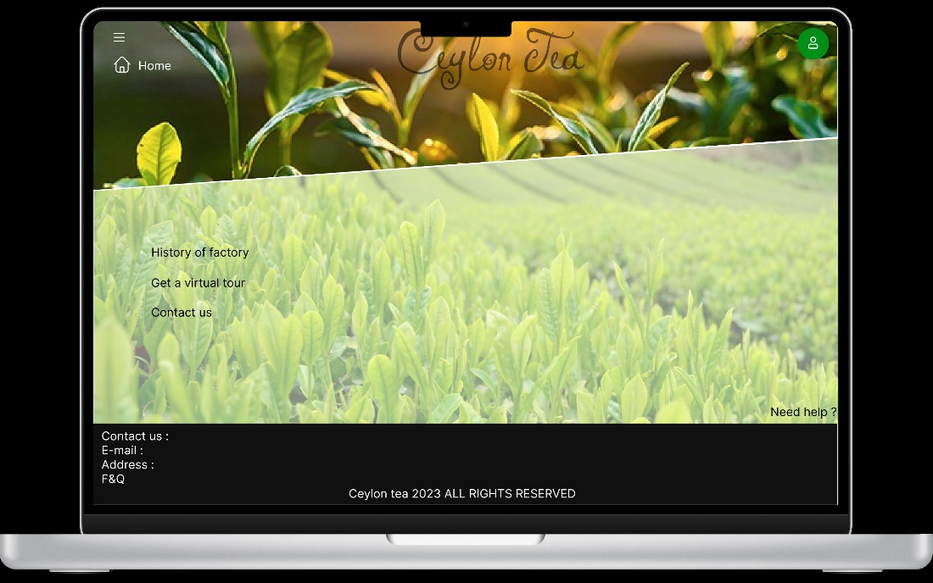

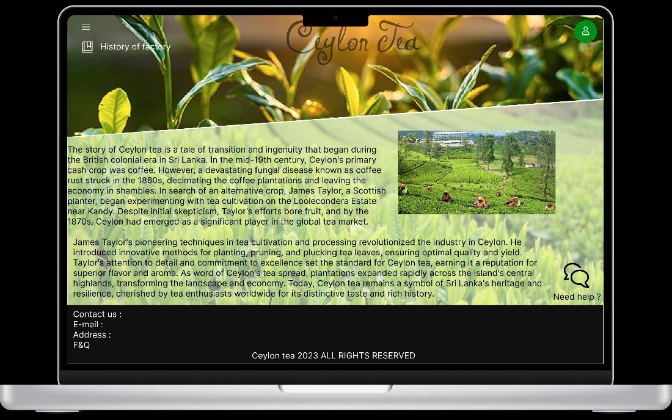

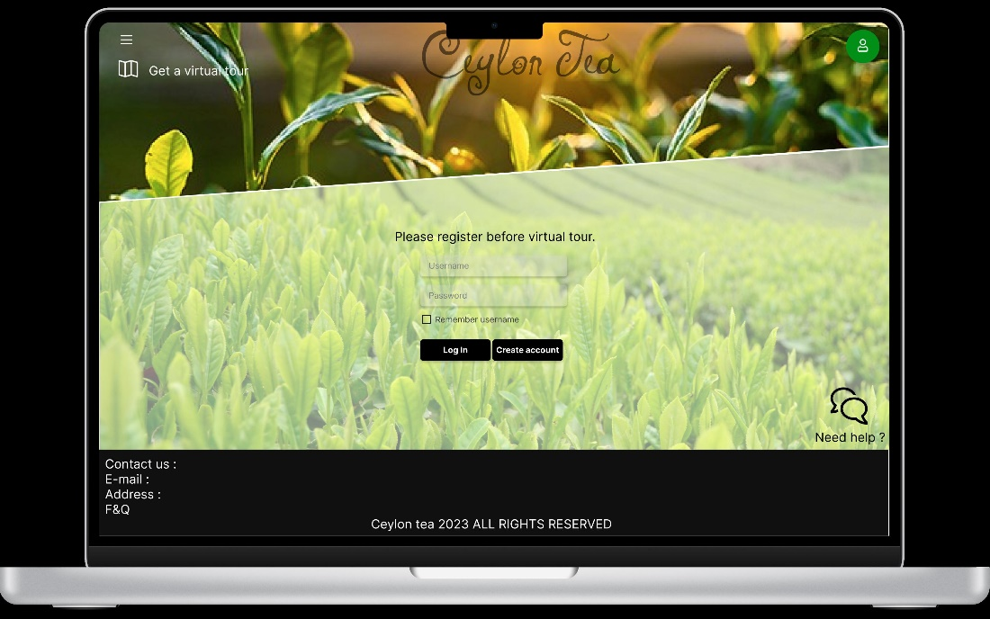

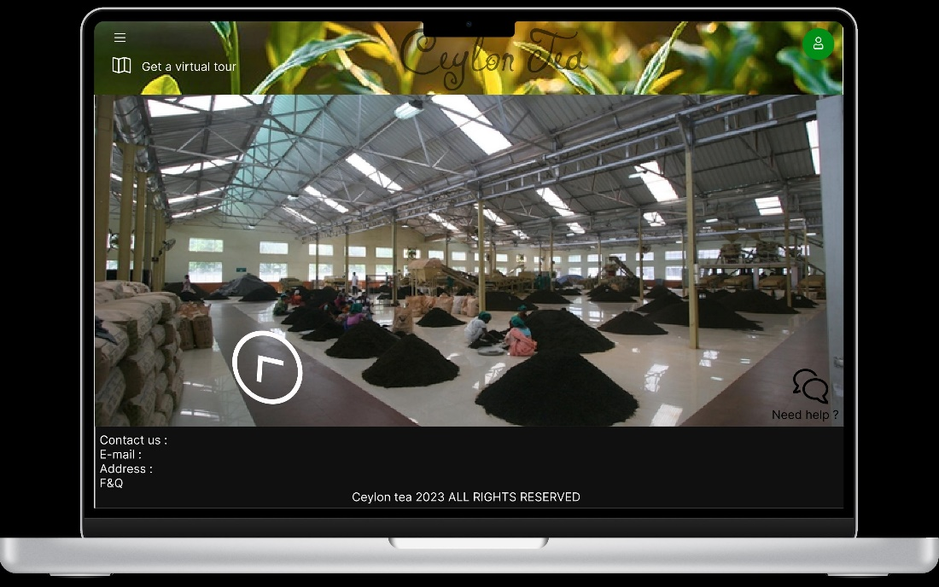

* Flow of the functionalities

Content creation - Provide multimedia content about the history, cultural legacy, and methods of tea production in Sri Lanka. This content should include photographs, videos, audio narrations, and informative text.

Virtual environment creation - Construct and produce virtual worlds that faithfully imitate actual tea plantations and factories to give viewers accuracy and immersion.

Interactive features - Use interactive features to keep users interested during the virtual tour, such as polls, quizzes, and clickable hotspots for further information.

Accessibility considerations - Make sure a wide range of users can access the virtual tours by including closed captioning, audio descriptions, and numerous language options.

Website integration - Visitors will find it easy to access the virtual tours if they are effectively integrated into the business's website.

User interface design - Provide a user-friendly interface that makes it simple for visitors to acquire pertinent information and move throughout the virtual tour.

Compatibility testing - To guarantee compatibility across a range of platforms and devices, such as desktops, laptops, tablets, and smartphones, thoroughly test the software.

Marketing strategy - Create a thorough marketing plan to advertise the virtual tours via a variety of platforms, including blogs, email newsletters, social media, and collaborations with travel companies.

Search engine optimization - Optimise the metadata and content of your website to increase search engine visibility and drive natural traffic to your virtual tours.

Targeted outreach - To maximise reach and engagement, identify and target certain audiences and demographics interested in tea tourism, both locally and abroad.

Data collection - Use analytics software to monitor metrics related to user engagement, such as the amount of time spent on the virtual tour, click-through rates, and visitor location.

Feedback mechanisms - Get customer feedback to find areas that need work and to learn more about their interests and preferences.

Performance evaluation - Maintain a close eye on the effectiveness of the virtual tours and make necessary adjustments to the content and promotional tactics in response to user feedback and analytics data.

Continues updates - To keep the virtual tours current and interesting for users, provide new features, material, and updates on a regular basis.

Expansion opportunities - Examine potential partnerships with other tourism industry players to broaden the virtual tour's audience and encourage environmentally friendly travel strategies.

Community engagement - Involve local groups and communities in the promotion of tea tourism and cultivate a sense of pride and ownership in Sri Lanka's tea legacy by interacting with them.

* Hardware/software requirements to deploy the system.
* Hardware

Server: A dependable server that can handle user interactions and host the content for the virtual tour. This server should be able to manage several people accessing the virtual tours at once with enough processing and storage power.

Network Infrastructure: A dependable internet connection with enough bandwidth to support user interactions during virtual tours and the seamless streaming of multimedia material.

Computing Devices: A range of computing devices, including tablets, smartphones, laptops, and desktop PCs, will be used by users to access the virtual tours. Verify compatibility with various screen sizes and device specs.

* Software

Virtual Tour Platform: To create and host the virtual tours, use a software programme or virtual tour platform. Alternatives include open-source platforms like Matterport, Panoroo, or Roundme, or proprietary virtual tour software.

Software tools for producing multimedia content include image, audio, and video editing programmes (Audacity, Adobe Audition, and Adobe Premiere Pro, Final Cut Pro, and Adobe Photoshop, among others).

Website Development Tools: HTML/CSS, JavaScript, and content management systems (like WordPress, Drupal) are required for website integration if you're creating a bespoke website to house the virtual tours.

Marketing and SEO Tools: To put marketing ideas into practice, improve the content of websites, and increase traffic to virtual tours, make use of marketing automation platforms, email marketing software, and SEO tools.

Accessibility Tools: Include features and tools for closed captioning, screen reader compatibility, and language translation on the website and virtual tour platform.

Security Measures: Put security measures in place to safeguard user information and guarantee the privacy, availability, and integrity of the virtual tour platform. This could involve firewall protection, frequent software upgrades, safe authentication procedures, and SSL/TLS encryption.

Solutions for Backup and Recovery: Install backup and recovery software to prevent data loss and guarantee service continuity in the event of hardware or software malfunctions. This could entail disaster recovery strategies and routine data backups to off-site locations.

* Special skills and knowledge required by the system users to work with

Content creators: proficiency with programmes for creating multimedia content, such as Adobe Premiere Pro, Final Cut Pro, Audacity, and Adobe Audition, as well as Adobe Photoshop, GIMP, and picture and audio editing programmes. Knowledge of Sri Lankan tea manufacturing techniques, history, and cultural significance is necessary to produce interesting and educational content for the virtual tours.

Expertise in creating virtual environments using 3D modelling, texturing, and animation utilising Unity or Unreal Engine software is required for virtual environment designers. Knowing the fundamentals and methods of virtual environment design to produce realistic and absorbing depictions of tea factories and farms.

Website developers should be proficient in content management systems (like WordPress and Drupal) and web development languages and frameworks like HTML/CSS and JavaScript. Knowledge of accessibility guidelines and user interface design principles to develop user-friendly interfaces for the website's virtual tours.

Marketing experts: familiarity with digital marketing tactics and instruments, including email, social media, and search engine optimisation (SEO) platforms. To create successful marketing campaigns and promotional activities for the virtual tours, it is important to understand the demographics and interests of the target audience in relation to tea tourism.

Analytics Experts: Capable of tracking user engagement metrics and deriving insights from data through proficiency with analytics tools like Google Analytics or Adobe Analytics. Knowledge of key performance indicators (KPIs) is necessary to assess the virtual tours' efficacy and make data-driven optimisation decisions.

Managers of Community Engagement: Excellent interpersonal and communication abilities to interact with local communities, organisations, and stakeholders in the tea tourist industry. Knowledge of cultural sensitivity and community engagement techniques to encourage cooperation and raise local community knowledge of the virtual tours.

IT and security administrators: To guarantee the security and dependability of the virtual tour system, possess expertise in IT infrastructure management and cybersecurity best practices. Acquiring knowledge about data privacy laws and compliance standards is necessary to safeguard user data and preserve system integrity.

* Limitations of the system

The virtual tour system's dependence on technology and internet access is a drawback for the promotion of tea tourism in Sri Lanka. Although virtual tours are convenient and accessible, people who are not comfortable navigating virtual settings or have restricted access to technology may not be able to use them. Furthermore, the rich sensory experience of visiting tea fields and factories in person might not be entirely replicated by virtual tours. Virtual environments may lose the subtle cultural differences and human interactions that make tea tourism so real. Furthermore, variables like user involvement, marketing tactics, and rivalry from other tourist spots affect how well virtual tours draw visitors and boost local economies. To optimise their impact, virtual tours should be combined with conventional marketing strategies and on-site experiences, even though they provide creative ways to promote tea tourism.

**Conclusion**

Our final report concludes with a comprehensive set of ideas targeted at transforming Sri Lanka's tea business through improved tea quality grading and creative tea tourism promotion. To take Sri Lanka's tea export industry to new heights of wealth and recognition, we have proposed customised systems and functions that address the shortcomings of conventional grading techniques and underutilised tourism potential.

Our suggested electronic grading technique eliminates the subjectivity of traditional approaches and provides a modern, efficient, and standardised approach to tea quality rating. We guarantee accuracy, consistency, and transparency in the grading process by utilising digital grading forms that are accessible through tablets or iPads, real-time evaluations, offline support, and strong data security measures. We do, however, recognise several limits, such as the requirement for user training, scalability issues, and technological dependencies, and we stress the significance of ongoing development and adaptation to get over these obstacles.

Our suggestion for virtual tours offers an engaging and approachable way to highlight the cultural and historical value of Sri Lanka's tea business, which is beneficial for developing tea tourism. We hope to engage a global audience and pique interest in visiting tea-growing countries by utilising interactive elements, multimedia material, and targeted marketing techniques. However, we are aware of the drawbacks of virtual experiences, such as technology constraints and the incapacity to perfectly capture the sensory depth of in-person encounters. To optimise their impact, we thus support a comprehensive strategy that combines virtual tours with conventional marketing initiatives and on-site encounters.

All things considered, our concluding analysis emphasises how crucial innovation, teamwork, and flexibility are to the expansion and long-term viability of Sri Lanka's tea sector. Our ideas, which integrate technology, standardisation, and community involvement, we think have the power to completely change the tea industry and guarantee its place in the world for years to come. We are convinced that our proposals will open the door to a better future for Sri Lanka's tea export industry and the related tourism sector, provided they are carefully put into practice and are continuously evaluated.